Benzene Exam Question
Q1. The hydrocarbons benzene and cyclohexene are both unsaturated compounds.
Benzene normally undergoes substitution reactions, but cyclohexene normally
undergoes addition reactions.
(a) The molecule cyclohexatriene does not exist and is described as hypothetical.
Use the following data to state and explain the stability of benzene compared with the hypothetical cyclohexatriene.
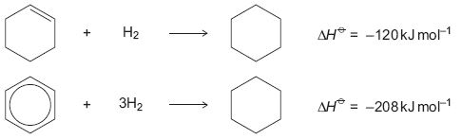
......................................................................................................................
......................................................................................................................
......................................................................................................................
......................................................................................................................
......................................................................................................................
......................................................................................................................
......................................................................................................................
......................................................................................................................
(Extra space) ...............................................................................................
......................................................................................................................
......................................................................................................................
......................................................................................................................
(4)

M1. (a) M1 Benzene is more stable than cyclohexatriene
more stable than cyclohexatriene must be stated or implied
If benzene more stable than cyclohexene, then penalise M1 but mark on
If benzene less stable: can score M2 only
1
M2 Expected ΔH^{ο} hydrogenation of C₆H₆ is 3(–120)
= –360 kJ mol⁻¹
Allow in words e.g. expected ΔH^{ο} hydrog is three times the ΔH^{ο} hydrog of cyclohexene
1

M3 Actual ΔH^{ο} hydrogenation of benzene is
152 kJ mol⁻¹ (less exothermic)
or 152 kJ mol⁻¹ different from expected
Ignore energy needed
1
M4 Because of delocalisation or electrons spread out or resonance
1

