Core practical 1: Measuring the molar volume of a gas
Commentary
The reaction between calcium carbonate and ethanoic acid produces carbon dioxide gas
CaCO₃(s) + 2CH₃COOH → Ca(CH₃COO)₂(aq) + H₂O(l) + CO₂(g)
1 mole of calcium carbonate produces 1 mole of carbon dioxide. By using different amounts of calcium carbonate a graph of mass of calcium carbonate against volume of carbon dioxide can be plotted and used to find the volume of carbon dioxide when 0.25 g (0.0025 mol) of calcium carbonate is used. This can then be scaled up to find the volume when 100 g (1 mol) of calcium carbonate is used. As the ratio is 1:1 this is the molar volume of carbon dioxide.
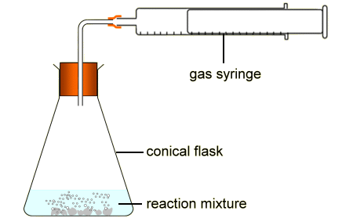
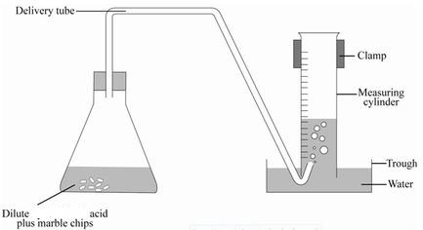
Key Apparatus – collection of a gas, two possible methods
Collection over water OK is this instance as CO₂ is not very soluble in water.
Safety
Ethanoic acid is an irritant – wear goggles
Chance of pressure build up in apparatus – make sure delivery tubing is clear from blockages
Processing Data – key skills involve graph plotting  Choose a sensible scale that is easy to follow and so the points cover at least half the available space  Make sure both axes are labelled, including units  Plot points carefully – errors cost marks!  Single line of best fit – could be curved. No ‘HAIRY’ lines.  Be able to find data, extrapolate, take tangents and calculate gradients if asked | Significant errors  Loss of gas after addition of acid but before replacement of bung – can be solved by placing CaCO₃ in a small open tube inside the flask with the acid already in. The flask is then tipped to mix the CaCO₃ with the acid.  Experimental result can be compared to true value e.g. suppose a value of 23.5 dm³ was found by experiment then 23.5/24.0 x 100 = 97.9% of true value (or 2.1 %).  Differences could be due to limitations of measurement (measurement uncertainty) or deviations from standard conditions

Core practical 2 : Preparing a standard solution from a solid acid
Commentary
An accurate, known mass of a solid acid can be dissolved in an accurately measured volume of water. Its concentration can be calculated and the solution used in a titration to find the concentration of a solution of alkali.
Apparatus – for making standard solution – Key practical tips
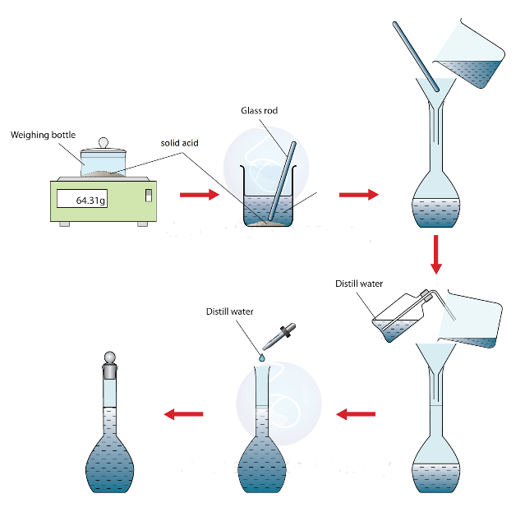
Weigh weighing bottle before and after, then subtract to find amount added – minimises transfer errors
Rinse beaker and rod to make sure all acid transferred to volumetric flask.
Shake flask before all the water is added to make sure acid is dissolved – if you leave it until all the water is added it’s difficult to shake as less room in flask
Use a dropping pipette to add last few cm³ of distilled water – if you go over your solution will be more dilute than you calculate
Bottom of meniscus needs to be on line of volumetric flask to give an accurate volume. Read at eye level.

Processing Data – key skills involve
- calculating amounts (mol) using amount (mol) = mass / molar mass
- calculating concentrations (mol dm⁻³) using concentration = amount (mol) / volume (dm³)
- calculating percentage errors due to limitations of equipment
Sample Results
1.23 g of sulfamic acid was dissolved in exactly 100 cm³ of distilled water, in a volumetric flask. Molar mass of sulfamic acid = 97.1 9 (g mol⁻¹)
Calculate amount of sulfamic acid (mol) = mass / molar mass = 1.23/97.1 = 0.01267 mol (in 100 cm³)
Concentration of sulfamic acid = 0.01267 x 1000/100 = 0.127 mol dm⁻³ (to 3SF so consistent with measurement data) – This uses the idea of scaling from 100 cm³ to 1000 cm³ (i.e. 1 dm³)
OR
Concentration of sulfamic acids = 0.01267 / (100/1000) = 0.127 mol dm⁻³ (to 3SF so consistent with measurement data) – This uses the equation with the volume converted to dm³)
Percentage uncertainties, e.g. the volumetric flask, can be calculated using measurement uncertainty / measurement , so for 100 cm³flask = ±0.15/100 x 100 = 0.15%
Core Practical 3 – Finding the concentration of a solution of HCl(aq) by titration
Commentary.
A sample of HCl(aq) is titrated against a standard solution of NaOH(aq), to find its concentration.
Apparatus for Titration
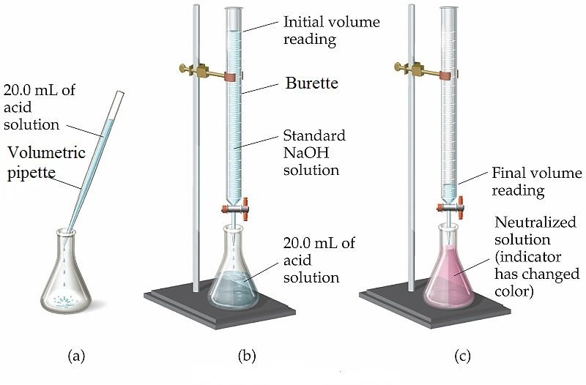
Use pipette filler to safely fill pipette
Use funnel to fill burette, but remove before use
Ensure no air bubble in bottom of burette
Read burette at eye-level, ±0.05 cm³
Swirl flask during titration
Rinse flask sides with distilled water. This DOES NOT affect the amounts of reactants.
Processing Data – sample results for 20.0 cm³ HCl with 0.0980 mol dm⁻³ NaOH
 | Rangefinder | Run 1 | Run 2
Final burette reading / cm³ | 20.10 | 39.90 | 19.70
Initial burette reading / cm³ | 0.00 | 20.10 | 0.00
Titre / cm³ | 20.10 | 19.80 | 19.70
Concordant | Do not use rangefinder | Y | Y

Average titre = (19.8 + 19.7) / 2 = 19.75 cm³
NaOH + HCl → NaCl + H₂O
Moles of NaOH = c x v = 0.098 x 19.75/1000 = 1.9355 x 10⁻³
1 : 1 reaction so moles of HCl (in 20 cm³) = 1.9355 x 10⁻³
So concentration of HCl = moles/v = 1.9355 x 10⁻³ /(20/1000) = 0.0968 mol dm⁻³ (to 3SF, as least accurate data is 3SF)
Evaluation
Percentage Uncertainties in burette and pipette readings can be quantified using
uncertainty / measurement x 100.
A potential unquantifiable errors could be air bubble in bottom of burette. This means the measured volume added from the burette is more than the actual volume. You can then process through what effect this would have on any calculation.

Core Practical 4 Investigation of the rates of hydrolysis of halogenoalkanes.
Samples of three primary halogenoalkanes are added to separate test tubes with small amounts of silver nitrate solution and ethanol. The test tubes are then warmed in a water bath. The water in the silver nitrate solution hydrolyses each halogenoalkane, forming an alcohol and a silver halide ppt. By timing the formation of the ppt, it can be determined which halogenoalkane reacts the fastest. The ethanol acts as a solvent, as the halogenoalkanes are not very soluble in water.
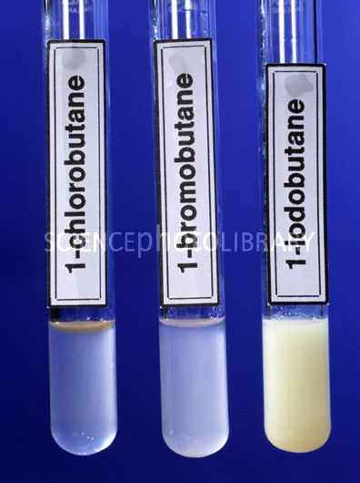
The order of reactivity is iodo > bromo > chloro
The explanation for this is linked to bond enthalpy.
The C-I bond is the weakest, so breaks first. The C-Br bond is stronger the C-I so 1-bromobutane reacts slower. The C-Cl bond is the strongest of the 3, so 1-chlorobutane reacts the slowest.

The equation for the formation of the ppt is;
Ag⁺(aq) + X⁻(aq) → AgX(s)
The organic equation is
CH₃CH₂CH₂CH₂X + H₂O → CH₃CH₂CH₂CH₂OH + HX

Core Practical 5 – The Oxidation of Ethanol
Commentary.
Primary alcohols can be partially oxidised to form aldehydes or completely oxidised to form carboxylic acids. The equipment used in each case can significantly influence the product. In both cases the oxidising agent is sodium dichromate(VI), acidified with sulfuric acid. The oxidising agent is reduced to Cr³⁺, giving a colour change of orange to green during the reaction

Partial Oxidation
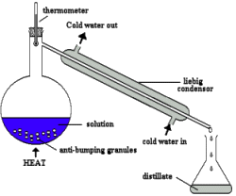
Anti bumping granules are used to stop violent bubbling as the solution boils
Distilling of the ethanal as it forms stops further oxidation to ethanoic acid
The production of ethanal can be confirmed by warming the sample with Fehlings Solution. If ethanal is present the Fehlings solution will turn from blue to red.
In diagrams make sure the thermometer is opposite the inlet to the condenser, that the water flow is the correct way round and that the apparatus is not completely sealed at the collection end, otherwise pressure will build up to potentially dangerous levels.
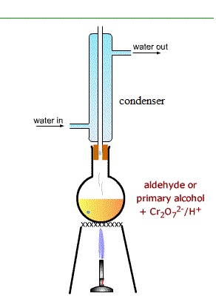
Complete Oxidation
Anti bumping granules are used to stop violent bubbling as the solution boils
Heating under reflux allows long periods of heating without loss of solvent. This allows time for complete oxidation to occur. It also minimises escape of flammable / harmful reactants or solvents into the atmosphere
The production of ethanoic acid can be confirmed by distilling of the acid from the reaction mixture, then adding a small amount of sodium carbonate to the sample. If ethanoic acid is present the bubbles of a colourless gas will be observed.
In diagrams make sure the condenser is not sealed at the top, that the water flow is the correct way round and that a heat source is indicated. An arrow pointing up to the flask, labelled ‘heat’ will suffice.
Safety Issues.
The sulfuric acid used is concentrated and must be added very slowly to the reaction mixture, as it can get very hot and cause the reaction mixture to boil out of the condenser if added too quickly. The sodium dichromate(VI) is toxic and carcinogenic so gloves should be worn when handling it.
Core Practical 6 – Chlorination of 2-methylpropan-2-ol with conc.HCl
Commentary
This is the preparation of a chloroalkane using c.HCl as a chlorinating agent. Other possible chlorinating agents include PCl₅ or SOCl₂. The reaction is simply carried out by mixing in a conical flask. However the separation and purification introduce the use of a separating funnel and drying agents for liquids, such as anhydrous sodium sulfate.
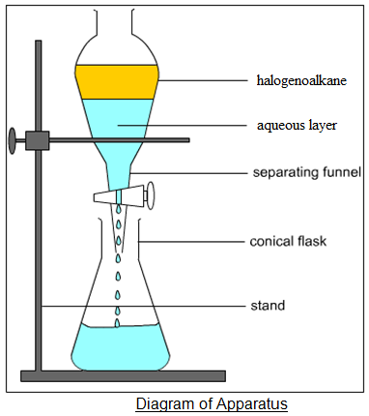
After the reaction the mixture is placed into a separating funnel and the 2 layers separate out. The aqueous layer is run off, and the remaining impure product is washed with NaHCO₃(aq) to neutralise any excess acid. CO₂ is also produced so the tap has to be opened periodically to release the build up of pressure. The washing solution of NaHCO₃(aq) is then run off, and the wet halogenoalkane is transferred to a conical flask. Anhydrous sodium sulfate is added until it stops clumping together. This absorbs any remaining water. The halogenoalkane is filtered off, then distilled, to increase the purity.

The yield of the experiment can be calculated using [actual yield / predicted (theoretical) yield] x 100. The units of the yields can be mol or grammes.
NOTE – as organic products / reactants are often liquids you may be given quantities as volumes. You can convert to mass using density = mass / volume. You will be given the density if needed.

Core Practical 7 – Analysis of Inorganic and Organic Unknowns
Commentary
A series of qualitative tests are used to help identify some unknown compounds
Inorganic Tests
Test | Description | Possible Outcomes
Flame test for metal cations | Clean nichrome wire with c.HCl. Place wire in sample, hold wire in edge of roaring Bunsen flame, record the flame colour observed | Li – Red  Na – Yellow  K - lilac | Mg – uv  Ca – Brick Red  Sr – Red  Ba – apple green
Test for halide ions | Add nitric acid, then silver nitrate solution to sample. Record colour of any precipitates. Check if precipitates dissolve in dil.NH₃, then c.NH₃ | Cl⁻ white ppt that dissolves in dil.NH₃  Br⁻ cream ppt that dissolves in c.NH₃  I⁻ yellow ppt that does NOT dissolve in c.NH₃
Test for sulfate ions | Add nitric acid, the barium chloride solution to sample. Look for appearance of a white ppt. | SO₄²⁻ - produces whit ppt
Oxidation of halide ions | Halide ions can be oxidised by a halogen that is a better oxidising agent. Small amounts of chlorine solution to samples that contain bromide ions will oxidise 2Br⁻ → Br₂ | Colourless to orange/brown as Br₂(aq) forms

Key Equations
Ag⁺(aq) + X⁻(aq) → AgX(s)
Ba²⁺(aq) + SO₄²⁻(aq) → BaSO₄(s)
2X⁻(aq) + Cl₂(aq) →2Cl⁻(aq) + X₂(aq)
Practical note – nitric acid is added along with the test reagent in both the halide and sulfate ion tests This to react with any CO₃²⁻ ions, which would also cause a ppt to form, if not removed.

Organic Tests
Test | Description | Possible Outcomes
Test for C=C functional group (alkenes) | Add small amount of bromine water and gently shake | Alkenes will cause the bromine water to decolourise (orange to colourless), forming a bromoalcohol
Test for OH functional group (alcohols) | Add acidified potassium dichromate and warm gently in a water bath | 1º and 2º alcohols cause the acidified potassium dichromate to change colour from orange to green. The alcohols are oxidised in the reaction.  3º alcohols would give no change.
Test for aldehydes (CHO) | Add Fehling’s solution and warm gently in a water bath | Aldehydes produce a red ppt. The aldehyde is oxidised – ketones do not give a positive result as they cannot be oxidised
Test for halogenoalkanes | Add ethanol and dilute sodium  hydroxide solution to a sample and warm the mixture in a water bath. Acidify each mixture with dilute nitric acid and then add 5 drops of silver nitrate solution. | RCl – white ppt  RBr – cream ppt  RI – yellow ppt
Test for carboxylic acids | Add small amount of Na₂CO₃ | Bubbles of colourless gas  NOTE phenol, though also acidic, is not a strong enough acid to displace carbon dioxide from carbonates

Core Practical 8 – Calculating the enthalpy change for the thermal decomposition of KHCO₃, using a Hess Cycle
Commentary
It is difficult to record temperature changes whilst heating a solid, so the enthalpy change for thermal decompostion reactions can be measured indirectly using a Hess Cycle.
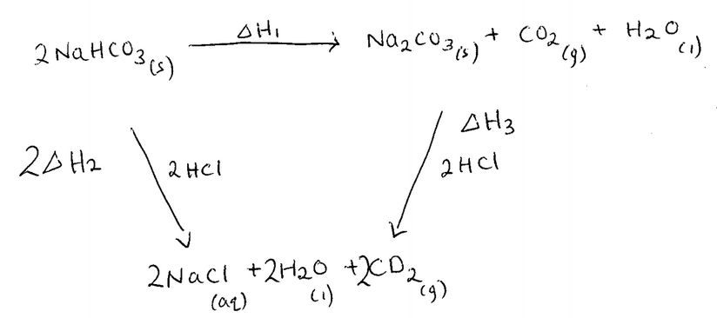
KHCO₃ and K₂CO₃ both react with HCl and the enthalpy change of these reactions determined using the results from a simle calorimetry experiment. (∆H2 and ∆H3)
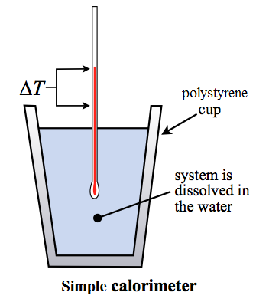
Known amount of KHCO₃ is mixed with a known volume (excess) of HCl. The temperature change is recorded.
Known amount of K₂CO₃ is mixed with a known volume (excess) of HCl. The temperature change is recorded
The temperature changes are used to calculate the energy changes.
The energy changes and amounts (in mol) are used to calculate the enthalpy changes.
The two enthalpy changes calculated using experimental data are then used to calculate the ehtnalpy change for the thermal decomposition.

Mass of solution is assumed to be equal to volume in cm³
Processing Data
calculate energy change for each experiment (in J) ; mass of solution x 4.18 x ∆T – Remember to convert to kJ before using in next step
calculate enthalpy change per mol for each experiment (kJ mol⁻¹) ; energy change (kJ) / amount (mol) – remember to put in sign to denote whether exo- or endothermic.
Use Hess cycle to calculate indirect enthalpy change
On cycle above ∆H1 + ∆H3 = 2∆H2, so ∆H1 = 2∆H2 - ∆H3
NOTE 2∆H2 is used as calculated enthalpy change from experiment is per mol, but 2 moles of NaHCO₃ in the balanced equation.
Possible Errors / Uncertainties
Heat losses to atmosphere by convection, heat losses to calorimeter by conduction, low resolution of scale on thermometer, resolution of balance

