Core Practical 9 – Finding the K_{a} for a weak acid using half neutralisation
Commentary
A sample of a weak acid is neutralised with NaOH, then the same amount of acid is added to the mixture formed. This means half of the total acid has been neutralised, which is helpful when processing the data. The pH is measured at this ‘half neutralisation’ point using a pH meter.
Practical Notes.
Equipment used is the same as for a titration, so same potential errors and uncertainties apply (see core practicals 2 and 3).
Processing Data
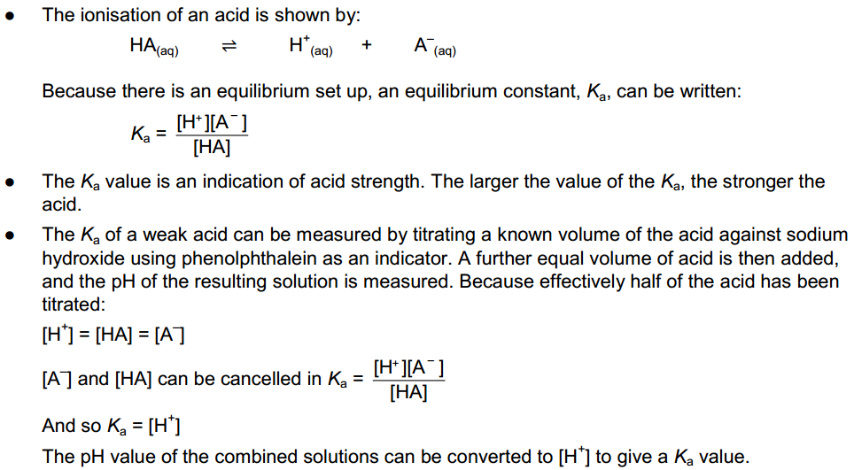
For instance if the pH was found to be 4.77, [H⁺] = shift log -4.77 = 10^{-4.77} = 1.7 x 10⁻⁵ mol dm⁻³ = K_{a}

Core Practical 10 – Constructing Electrochemical cells and Measuring the Cell Potential
Commentary.
A series of simple electrochemical cells are set up and their potentials measured. Differences from standard E_{cell} values are considered.
Practical Notes
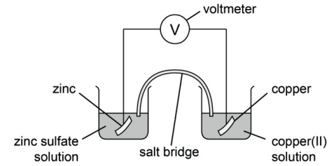
For standard values solutions should be 1 mol dm⁻³.
Salt bridge consists of filter paper soaked in saturated potassium nitrate solution.
The role of the salt bridge is to replace the ions that are either oxidised or reduced in each half cell, thus allowing the flow of electrons to continue fron the negative to the positive electrode. For instance in the above cell, on the RHS copper ions leave the solution to form copper atoms. Without the salt bridge an excess of negative sulfate ions would build up, preventing the flow of electrons to this side of the cell. With the salt bridge, the lost copper ions are replaced by potassium ions, so maintaining electrical neutrality.
Cell Diagrams
The above cell can be represented by a cell diagram,
The single solid lines represent a change in physical state, the double solid lines represent the salt bridge.
By convention E_{cell} = E_{R} – E_{L}, in this case +0.34 – (-0.76) = +1.10V
The Zn is the negative electrode, the Cu the positive. Electrode potentials are quoted in questions as necessary OR in the data booklet used in the exam.
In practice the measured values may differ from calculated values, as the conditions are not standard. For instance if Mg is used it may react with water to form Mg²⁺ ions. This will cause the half-cell equilibrium to shift to the right
Mg²⁺(aq) + 2 e ⇌ Mg(s).
Hence Eº would be less negative, so E_{cell} with a less reactive metal would be less positive.

Core Practical 11 Redox Titration – Percentage of Fe in iron tablets
Commentary
This is a redox titration as Fe²⁺ ions are oxidised by MnO₄⁻ ions to form Fe³⁺ and Mn²⁺. The reaction is self-indicating, as the slight excess of MnO₄⁻ ions at the end point give the reaction mixture a pale purple colour.
The active ingredient of the tablets is FeSO₄, iron(II) sulfate. Tablets are crushed in a mortar and pestle, with a little dil.sulfuric acid. The paste is rinsed into a volumetric flask using more dil.sulfuric acid, and made up to exactly 250.0 cm³ Acid is used rather than water as the reaction with MnO₄⁻ requires H⁺ ions. 25.0 cm³ samples of the solution is titrated with MnO₄⁻ of concentration = 0.00500 mol dm⁻³

The equation for the reaction is
5Fe²⁺ + MnO₄⁻ + 8H⁺ → 5Fe³⁺ + Mn²⁺ + 4H₂O ; you may be expected to construct this, or other redox equations by using information from the question to help write half equations, then combine the two half equations together to a full equation. This will gave you the reacting ratio (stoichiometry) between the reactants.

Processing Data – Sample results
Concentration of MnO₄⁻(aq) = 0.00500 mol dm⁻³
Volume of ‘iron tablet’ solution used in each titre = 25.0 cm³
Average volume of MnO₄⁻(aq) = 21.20 cm³ (Note titres to 2 dp, 2nd dp 0 or 5)
- Amount of MnO₄⁻(aq) = 21.2/1000 x 0.005 = 1.06 x 10⁻⁴ mol
- So Amount of Fe²⁺ (in 25.0 cm³ sample) = 1.06 x 10⁻⁴ x 5 = 5.3 x 10⁻⁴ mol
- So amount of Fe²⁺ from tablets (i.e. in 250.0 cm³ sample) = 5.3 x 10⁻⁴ x 10 = 5.3 x 10⁻³ mol
- Mass of FeSO₄ in 2 tablets = 5.3 x 10⁻³ x 151.9 = 0.805 g
- Mass of Fe in 2 tablets = 5.3 x 10⁻³ x 55.8 = 0.296 g
Possible errors
- difficult to confirm all of FeSO₄ has dissolved / mixed evenly – stirring thoroughly, gentle heating and inverting volumetric flask several times may help
- reactant from tablets may be lost in transfer errors, e.g. from mortar – ensure all equipment is rinsed and rinsings transferred to volumetric flask

Core Practical 12 – Preparation of a Transition Metal Complex
Commentary
The procedure followed for the reaction involves preparing a solution of Cu(H₂O)₆²⁺(aq), then adding conc.NH₃ to convert to the solid complex Cu(NH₃)₄SO₄•H₂O.
The most significant part of the process is the separation by vacuum filtration, followed by washing with cold ethanol and drying.
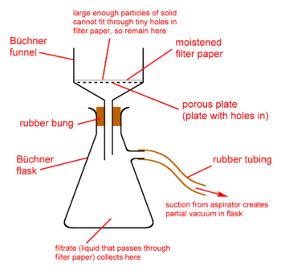
Vacuum (or Buchner) filtration is more effective than gravity filtration as it is;
- Faster
- Removes more of the solvent so solid collected is dryer
The product is washed in cold ethanol to reduce product lost by dissolving during washing.
The product is patted dry on pieces of filter paper or left in a desiccator.

Once dry, the yield of the product is measured, by mass. The percentage yield can be calculated using (actual yield / predicted yield) x 100.
Possible reasons to explain loss of product include;
Reaction to form complex does not go to completion
Some of the complex remains in solution
If the percentage yield is greater than 100%, the mass must include other compounds, almost certainly water, due to the crystals still being wet.

Core Practical 13A – Investigating the Kinetics of the Iodine-Propanone reaction using the continuous monitoring method.
Commentary
Iodine will react with propanone in the presence of H⁺ ions. By using a reaction mixture with excess propanone and H⁺ but iodine as the limiting reactant, the order wrt iodine can be found.
In the continuous monitoring method, samples of the reaction mixture are removed at fixed times, quenched to stop further reaction, and then studied to determine the concentration of the reactant.
A graph of concentration against time can be used to determine order.
In this case the reaction is quenched by adding NaHCO₃ to neutralise the acid. The iodine present is then determined by titrating with sodium thiosulfate solution. As the volume of the titre is proportional to the concentration of the iodine, this can be plotted against time, rather than the concentration.
Processing Results
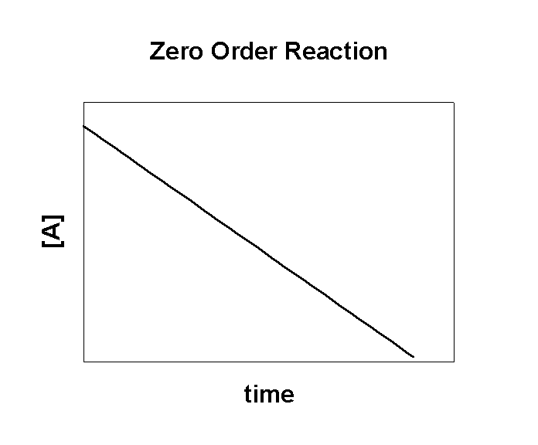
All the usual rules for graph plotting apply. Once plotted the order can be found.

A graph that shows zero order would show no change in gradient (i.e. rate) over time. The reactant involved would NOT be part of the rate determining step of the mechanism

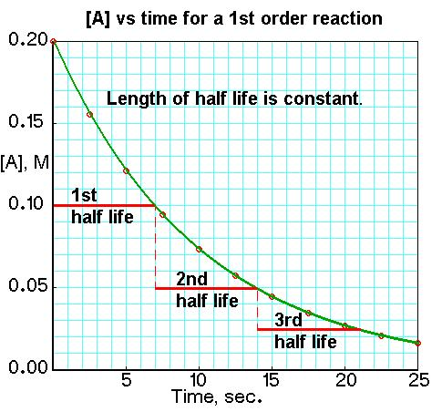
A graph that shows first order would show a change in gradient (i.e. rate) over time, as the concentration of the reactant decreases. The half-life of the graph would remain constant. One molecule of the reactant involved WOULD be part of the rate determining step of the mechanism

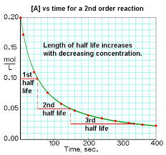
A graph that shows second order would show a more dramatic change in gradient (i.e. rate) over time, as the concentration, as the concentration of the reactant decreases. Each successive half-life of the graph would approximately double. Two molecules of the reactant involved WOULD be part of the rate determining step of the mechanism

Core Practical 13B – A Clock Reaction (Initial Rates Method)
Clock reactions use a range of different concentrations of reactants and the time for a significant event recorded. In this case the reaction is between peroxodisulfate ions (S₂O₈²⁻) and iodide ions (I⁻) in the presence of starch. The iodide ions are oxidised to iodine (I₂). The reaction mixture also contains a fixed amount of sodium thiosulfate solution, which immediately reduces the iodine, (I₂), back to iodide ions (I⁻). Once all the sodium thiosulfate solution is used up, the iodine reacts with the starch and the mixture turns blue. The time for this is noted and can be used to determine the order wrt reactants.
Sample Results
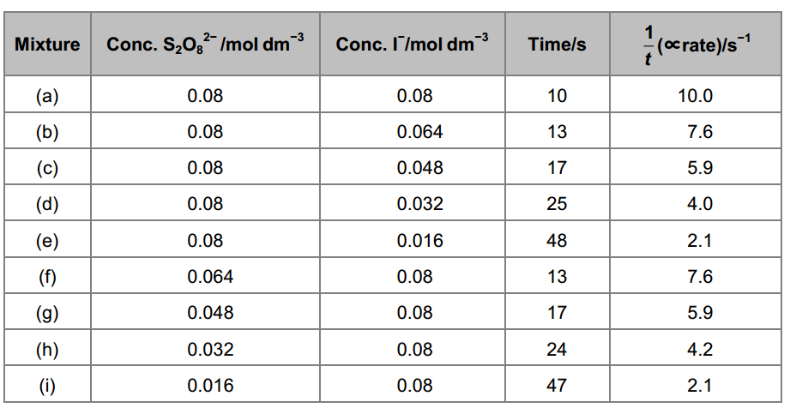
Processing Results
Graphs of rate against concentration can be plotted to find order.
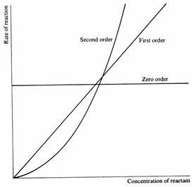
In this case, both reactants give a first order graph so the rate equation would be;
Rate = k[I⁻][S₂O₈²⁻]
The orders can also be determined by comparing different sets of data. For instance in runs (b) and (d) [S₂O₈²⁻] stays constant but [I⁻] halves (0.064 → 0.032). The rate also halves (7.6 → 4), so must be first order wrt [I⁻]

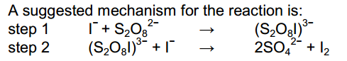
This fits with the orders as one step involves one mole of both I⁻ and S₂O₈²⁻. This would be the RDS.
Core Practical 14 – Experiment to determine the activation energy of a reaction.
Commentary
Phenol can react with bromine to produce 2,4,6 – tribromophenol. The time taken for the reaction can be measured at different temperatures. This is achieved by using a small amount of the red indicator, methyl red, in the reaction mixture. Once all the phenol has reacted the excess bromine decolourises the methyl red, indicating the end of the reaction.
Processing the data
Convert temperatures (T) from ºC to K (+273)
Calculate 1/T (K⁻¹)
Calculate 1/time (s⁻¹). This is proportional to the rate of the reaction.
Calculate ln(1/time) – sometimes called ln(rate)
Plot a graph of ln(rate) against 1/time – this will give a straight line graph with a negative gradient like this;
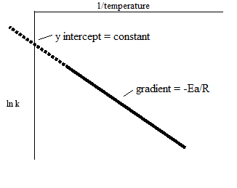
The Arrhenius equation can be shown in the form ln k = – (E_{a}/R)(1/T) + constant

y = mx + c
The gradient will have a negative value.
Ea = -gradient x R
Hence Ea will have a positive value in Joules.

Core Practical 15 – Inorganic and organic analysis of unknowns.
Commentary
This task revisits qualitative tests for cation, anions and functional groups. The results are used to identify several unknown compounds.
The tests involved are
Test | Description | Possible Outcomes
Flame test for metal cations | Clean nichrome wire with c.HCl. Place wire in sample, hold wire in edge of roaring Bunsen flame, record the flame colour observed | Li – Red  Na – Yellow  K - lilac | Mg – uv  Ca – Brick Red  Sr – Red  Ba – apple green
Test for cations using NaOH(aq) | Dissolve sample, then add NaOH(aq) drop by drop, until there is no further change | See below
Test for halide ions | Add nitric acid, then silver nitrate solution to sample. Record colour of any precipitates. Check if precipitates dissolve in dil.NH₃, then c.NH₃ | Cl⁻ white ppt that dissolves in dil.NH₃  Br⁻ cream ppt that dissolves in c.NH₃  I⁻ yellow ppt that does NOT dissolve in c.NH₃
Test for sulfate ions | Add nitric acid, the barium chloride solution to sample. Look for appearance of a white ppt. | SO₄²⁻ - produces whit ppt
Test for carbonate ions | Add dil.HCl to solid sample. Bubble gas produced through limewater | Limewater turns milky to indicate solid sample contained carbonate ions.

Possible outcomes for the cation tests are;
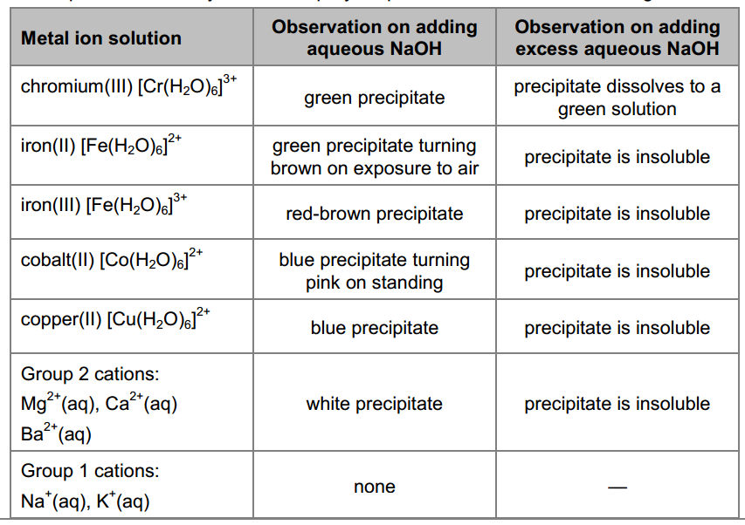

Organic Tests
Test | Description | Possible Outcomes
Test for C=C functional group (alkenes) | Add small amount of bromine water and gently shake | Alkenes will cause the bromine water to decolourise (orange to colourless), forming a bromoalcohol
Test for OH functional group (alcohols) | Add acidified potassium dichromate and warm gently in a water bath | 1º and 2º alcohols cause the acidified potassium dichromate to change colour from orange to green. The alcohols are oxidised in the reaction.  3º alcohols would give no change.
Test for aldehydes (CHO) | Add Fehling’s solution and warm gently in a water bath | Aldehydes produce a red ppt. The aldehyde is oxidised – ketones do not give a positive result as they cannot be oxidised
Test for halogenoalkanes | Add ethanol and dilute sodium  hydroxide solution to a sample and warm the mixture in a water bath. Acidify each mixture with dilute nitric acid and then add 5 drops of silver nitrate solution. | RCl – white ppt  RBr – cream ppt  RI – yellow ppt
Test for carboxylic acids | Add small amount of Na₂CO₃ | Bubbles of colourless gas  NOTE phenol, though also acidic, is not a strong enough acid to displace carbon dioxide from carbonates
Alternative test for carboxylic acids | Add ethanol and a few drops of c.H₂SO₄. Warm test tube in a water bath. Neutralize excess acid with sodium carbonate solution. Cautiously smell product | If a carboxylic acid was present an ester will form, giving a fruity smell.

The organic tests will only indicate functional groups. To determine the structure other data is required. This could include;
- Combustion data to allow calculation of empirical formula
- Mass spectra – to find M_{r}
- IR spectra – to confirm presence of functional groups
- NMR spectra – to confirm structure

Core Practical 16 – Preparation of aspirin.
Commentary
The aspirin is made by an esterification reaction between 2-hydroxybenzoic acid and ethanoic anhydride.
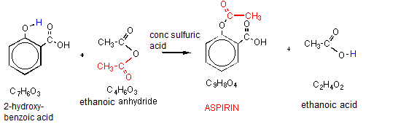
The hydrogen on the phenol -OH group is replaced by the -COCH₃ from the ethanoic anhydride. Ethanoic anhydride is used rather than ethanoic acid as it is more reactive, because CH₃COO⁻ is a better leaving group than OH⁻.
The reaction is heated under reflux (see core practical 5 – oxidation of alcohols). The solid impure product is then separated by vacuum filtration (see core practical 12 – TM complex formation).
Purification.
Solid products are purified by recrystallization. The key parts of the process are;

Procedure | Justification
Dissolve impure product in minimum volume of hot solvent. | Product should be soluble in hot solvent, but sparingly soluble in cold solvent. Impurities should remain dissolved in hot and cold. Minimum volume is used to minimize the amount of product that remains in solution
Use a hot gravity filtration to remove any insoluble impurities | The filter funnel and paper have to be heated to prevent any product recrystallizing on the paper or funnel
Cool solution in ice bath to ensure crystals form | Product is much less soluble in cold solvent. Scratching the side of the flask with a glass rod encourages crystallization
Filter using vacuum filtration | Vacuum filtration is faster and removes more of the solvent
Wash crystals with cold solvent | Cold solvent prevents product re-dissolving
Dry between pieces of filter paper / in desiccator | Ensures product is dry so purity can be checked

The technique works because the impurities, present in small amount, remain dissolved both in hot and cold. Most of the product however recrystallizes at the lower temperature. You are not expected to choose a solvent, but you are expected to understand its role in the process. The purity of the product can be checked by determine the melting point of the sample and comparing it to known values.
Measuring a melting point.
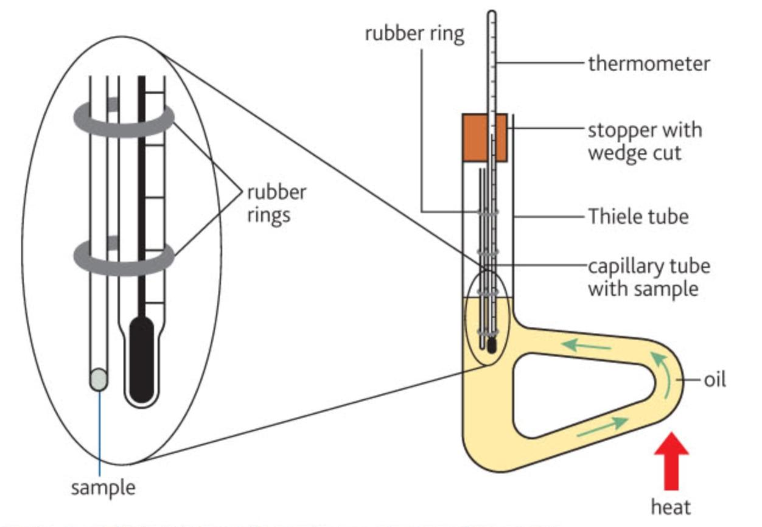
Gentle heating of the oil sets up a convection current to warm up the sample in the capillary tube. The temperatures at which the sample starts to melt and when melting is complete are noted. A sharp melting point with a narrow range (1 or 2 degrees), in line with the value from data book sources, means the substance is pure. A wide range, or value different from data book values, suggests the product is impure.

