COVALENT BONDING - SINGLE BONDS

This page explains what covalent bonding is. It starts with a simple picture of the single covalent bond, and then modifies it slightly for A'level purposes. It also takes a more sophisticated view (beyond A'level) if you are interested. You will find a link to a page on double covalent bonds at the bottom of the page.

A simple view of covalent bonding
The importance of noble gas structures
At a simple level (like GCSE) a lot of importance is attached to the electronic structures of noble gases like neon or argon which have eight electrons in their outer energy levels (or two in the case of helium). These noble gas structures are thought of as being in some way a "desirable" thing for an atom to have.
You may well have been left with the strong impression that when other atoms react, they try to achieve noble gas structures.
As well as achieving noble gas structures by transferring electrons from one atom to another as in ionic bonding, it is also possible for atoms to reach these stable structures by sharing electrons to give covalent bonds.
Some very simple covalent molecules
Chlorine
For example, two chlorine atoms could both achieve stable structures by sharing their single unpaired electron as in the diagram.
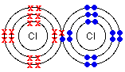
The fact that one chlorine has been drawn with electrons marked as crosses and the other as dots is simply to show where all the electrons come from. In reality there is no difference between them.
The two chlorine atoms are said to be joined by a covalent bond. The reason that the two chlorine atoms stick together is that the shared pair of electrons is attracted to the nucleus of both chlorine atoms.
Hydrogen
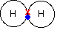
Hydrogen atoms only need two electrons in their outer level to reach the noble gas structure of helium. Once again, the covalent bond holds the two atoms together because the pair of electrons is attracted to both nuclei.
Hydrogen chloride
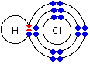
The hydrogen has a helium structure, and the chlorine an argon structure.

Covalent bonding at A'level
Cases where there isn't any difference from the simple view
If you stick closely to modern A'level syllabuses, there is little need to move far from the simple (GCSE) view. The only thing which must be changed is the over-reliance on the concept of noble gas structures. Most of the simple molecules you draw do in fact have all their atoms with noble gas structures.
For example:
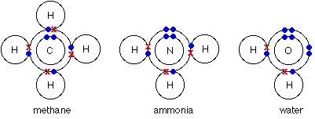
Even with a more complicated molecule like PCl₃, there's no problem. In this case, only the outer electrons are shown for simplicity. Each atom in this structure has inner layers of electrons of 2,8. Again, everything present has a noble gas structure.
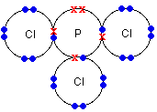
Cases where the simple view throws up problems
Boron trifluoride, BF₃
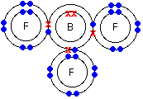
A boron atom only has 3 electrons in its outer level, and there is no possibility of it reaching a noble gas structure by simple sharing of electrons. Is this a problem? No. The boron has formed the maximum number of bonds that it can in the circumstances, and this is a perfectly valid structure.
Energy is released whenever a covalent bond is formed. Because energy is being lost from the system, it becomes more stable after every covalent bond is made. It follows, therefore, that an atom will tend to make as many covalent bonds as possible. In the case of boron in BF₃, three bonds is the maximum possible because boron only has 3 electrons to share.
Note: You might perhaps wonder why boron doesn't form ionic bonds with fluorine instead. Boron doesn't form ions because the total energy needed to remove three electrons to form a B³⁺ ion is simply too great to be recoverable when attractions are set up between the boron and fluoride ions.

Phosphorus(V) chloride, PCl₅
In the case of phosphorus 5 covalent bonds are possible - as in PCl₅.
Phosphorus forms two chlorides - PCl₃ and PCl₅. When phosphorus burns in chlorine both are formed - the majority product depending on how much chlorine is available. We've already looked at the structure of PCl₃.
The diagram of PCl₅ (like the previous diagram of PCl₃) shows only the outer electrons.
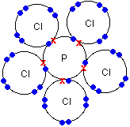
Notice that the phosphorus now has 5 pairs of electrons in the outer level - certainly not a noble gas structure. You would have been content to draw PCl₃ at GCSE, but PCl₅ would have looked very worrying.
Why does phosphorus sometimes break away from a noble gas structure and form five bonds? In order to answer that question, we need to explore territory beyond the limits of current A'level syllabuses. Don't be put off by this! It isn't particularly difficult, and is extremely useful if you are going to understand the bonding in some important organic compounds.

A more sophisticated view of covalent bonding
The bonding in methane, CH₄
Warning! If you aren't happy with describing electron arrangements in s and p notation, and with the shapes of s and p orbitals, you need to read about orbitals before you go on.
Use the BACK button on your browser to return quickly to this point.

What is wrong with the dots-and-crosses picture of bonding in methane?
We are starting with methane because it is the simplest case which illustrates the sort of processes involved. You will remember that the dots-and-crossed picture of methane looks like this.
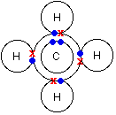
There is a serious mis-match between this structure and the modern electronic structure of carbon, 1s²2s²2p_{x}¹2p_{y}¹. The modern structure shows that there are only 2 unpaired electrons for hydrogens to share with, instead of the 4 which the simple view requires.
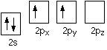
You can see this more readily using the electrons-in-boxes notation. Only the 2-level electrons are shown. The 1s² electrons are too deep inside the atom to be involved in bonding. The only electrons directly available for sharing are the 2p electrons. Why then isn't methane CH₂?
Promotion of an electron
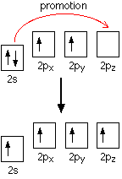
When bonds are formed, energy is released and the system becomes more stable. If carbon forms 4 bonds rather than 2, twice as much energy is released and so the resulting molecule becomes even more stable.
There is only a small energy gap between the 2s and 2p orbitals, and so it pays the carbon to provide a small amount of energy to promote an electron from the 2s to the empty 2p to give 4 unpaired electrons. The extra energy released when the bonds form more than compensates for the initial input.

The carbon atom is now said to be in an excited state.
Note: People sometimes worry that the promoted electron is drawn as an up-arrow, whereas it started as a down-arrow. The reason for this is actually fairly complicated - well beyond the level we are working at. Just get in the habit of writing it like this because it makes the diagrams look tidy!

Now that we've got 4 unpaired electrons ready for bonding, another problem arises. In methane all the carbon-hydrogen bonds are identical, but our electrons are in two different kinds of orbitals. You aren't going to get four identical bonds unless you start from four identical orbitals.
Hybridisation
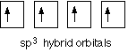
The electrons rearrange themselves again in a process called hybridisation. This reorganises the electrons into four identical hybrid orbitals called sp³ hybrids (because they are made from one s orbital and three p orbitals). You should read "sp³" as "s p three" - not as "s p cubed".
sp³ hybrid orbitals look a bit like half a p orbital, and they arrange themselves in space so that they are as far apart as possible. You can picture the nucleus as being at the centre of a tetrahedron (a triangularly based pyramid) with the orbitals pointing to the corners. For clarity, the nucleus is drawn far larger than it really is.

What happens when the bonds are formed?
Remember that hydrogen's electron is in a 1s orbital - a spherically symmetric region of space surrounding the nucleus where there is some fixed chance (say 95%) of finding the electron. When a covalent bond is formed, the atomic orbitals (the orbitals in the individual atoms) merge to produce a new molecular orbital which contains the electron pair which creates the bond.
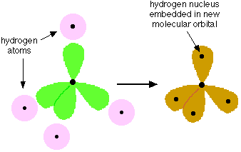
Four molecular orbitals are formed, looking rather like the original sp³ hybrids, but with a hydrogen nucleus embedded in each lobe. Each orbital holds the 2 electrons that we've previously drawn as a dot and a cross.
The principles involved - promotion of electrons if necessary, then hybridisation, followed by the formation of molecular orbitals - can be applied to any covalently-bound molecule.
Note: You will find this bit on methane repeated in the organic section of this site. That article on methane goes on to look at the formation of carbon-carbon single bonds in ethane.

The bonding in the phosphorus chlorides, PCl₃ and PCl₅
What's wrong with the simple view of PCl₃?
This diagram only shows the outer (bonding) electrons.
Nothing is wrong with this! (Although it doesn't account for the shape of the molecule properly.) If you were going to take a more modern look at it, the argument would go like this:
Phosphorus has the electronic structure 1s²2s²2p⁶3s²3p_{x}¹3p_{y}¹3p_{z}¹. If we look only at the outer electrons as "electrons-in-boxes":
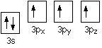
There are 3 unpaired electrons that can be used to form bonds with 3 chlorine atoms. The four 3-level orbitals hybridise to produce 4 equivalent sp³ hybrids just like in carbon - except that one of these hybrid orbitals contains a lone pair of electrons.
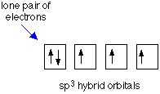
Each of the 3 chlorines then forms a covalent bond by merging the atomic orbital containing its unpaired electron with one of the phosphorus unpaired electrons to make 3 molecular orbitals.
You might wonder whether all this is worth the bother! Probably not! It is worth it with PCl₅, though.
What's wrong with the simple view of PCl₅?
You will remember that the dots-and-crosses picture of PCl₅ looks awkward because the phosphorus doesn't end up with a noble gas structure. This diagram also shows only the outer electrons.
In this case, a more modern view makes things look better by abandoning any pretence of worrying about noble gas structures.
If the phosphorus is going to form PCl₅ it has first to generate 5 unpaired electrons. It does this by promoting one of the electrons in the 3s orbital to the next available higher energy orbital.
Which higher energy orbital? It uses one of the 3d orbitals. You might have expected it to use the 4s orbital because this is the orbital that fills before the 3d when atoms are being built from scratch. Not so! Apart from when you are building the atoms in the first place, the 3d always counts as the lower energy orbital.
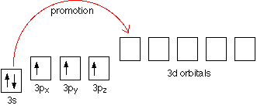
This leaves the phosphorus with this arrangement of its electrons:
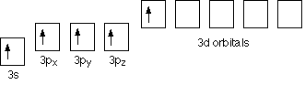
The 3-level electrons now rearrange (hybridise) themselves to give 5 hybrid orbitals, all of equal energy. They would be called sp³d hybrids because that's what they are made from.
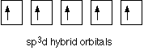
The electrons in each of these orbitals would then share space with electrons from five chlorines to make five new molecular orbitals - and hence five covalent bonds.
Why does phosphorus form these extra two bonds? It puts in an amount of energy to promote an electron, which is more than paid back when the new bonds form. Put simply, it is energetically profitable for the phosphorus to form the extra bonds.
The advantage of thinking of it in this way is that it completely ignores the question of whether you've got a noble gas structure, and so you don't worry about it.

A non-existent compound - NCl₅
Nitrogen is in the same Group of the Periodic Table as phosphorus, and you might expect it to form a similar range of compounds. In fact, it doesn't. For example, the compound NCl₃ exists, but there is no such thing as NCl₅.
Nitrogen is 1s²2s²2p_{x}¹2p_{y}¹2p_{z}¹. The reason that NCl₅ doesn't exist is that in order to form five bonds, the nitrogen would have to promote one of its 2s electrons. The problem is that there aren't any 2d orbitals to promote an electron into - and the energy gap to the next level (the 3s) is far too great.
In this case, then, the energy released when the extra bonds are made isn't enough to compensate for the energy needed to promote an electron - and so that promotion doesn't happen.
Atoms will form as many bonds as possible provided it is energetically profitable.

