Year 13: Chemistry Work Sheet – Monday 4th December
Do Now (4 marks):

Esters have many important commercial uses such as solvents and artificial flavourings in foods.

Esters can be prepared in several ways including the reactions of alcohols with carboxylic acids, acid anhydrides, acyl chlorides and other esters.

(a) Ethyl butanoate is used as a pineapple flavouring in sweets and cakes.

Write an equation for the preparation of ethyl butanoate from an acid and an alcohol.

Give a catalyst used for the reaction

______________________________________________________________________________________________________________________________________________________________________________________________________________________________________________________________________________________________________________________________________________________________________________________________________________________________________________________________________________________________________________________________________

Polyester Exam Question (7 marks):

Repeating units of two polymers, P and Q, are shown in the figure below.

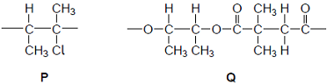

(a) Draw the structure of the monomer used to form polymer P.
Name the type of polymerisation involved.

Monomer

Type of polymerisation ....................................................................................

(2)

(b) Draw the structures of two compounds that react together to form polymer Q.

Structure of compound 1

Structure of compound 2

(2)

(c) Suggest an environmental advantage of polymer Q over polymer P.
Justify your answer.

Advantage .....................................................................................................

Justification ....................................................................................................

........................................................................................................................

........................................................................................................................

........................................................................................................................

........................................................................................................................

(3)

Polyamide Exam Question:

The amide or peptide link is found in synthetic polyamides and also in naturally
occurring proteins.

(a) (i) Draw the repeating unit of the polyamide formed by the reaction of propanedioic acid with hexane-1,6-diamine.

(2)

(ii) In terms of the intermolecular forces between the polymer chains, explain why polyamides can be made into fibres suitable for use in sewing and weaving, whereas polyalkenes usually produce fibres that are too weak for this purpose.

.............................................................................................................

.............................................................................................................

.............................................................................................................

.............................................................................................................

.............................................................................................................

.............................................................................................................

(3)

Do Now Answers:

M1 CH₃CH₂CH₂COOH

not C₃H₇COOH

1

M2 CH₃CH₂OH or C₂H₅OH

1

M3 CH₃CH₂CH₂COOCH₂CH₃ + H₂O

allow C₃H₇COOC₂H₅
penalise M3 for wrong products and unbalanced equation

1

M4 H₂SO₄ or HCl or H₃PO₄ conc or dil or neither

not HNO₃

1

Polyester Exam Answers:

(a)

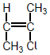

1

Addition

1

(b)
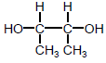

1

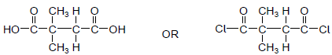

1

(c) Q is biodegradable

1

Polar C=O group or δ+ C in Q (but not in P)

1

Therefore, can be attacked by nucleophiles (leading to breakdown)

1

[7]

Polyamide Exam Answers:

(a) (i)

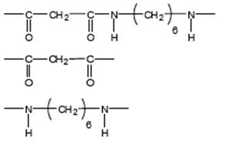

Allow –CONH- or - COHN -

Mark two halves separately

lose 1 each for missing trailing bonds at one or both ends or error in peptide link or either or both of H or OH on ends

1

Not allow –(C₆H₁₂)–

Ignore n

1

(ii) M1 in polyamides - H bonding

1

M2 in polyalkenes - van der Waals forces

Penalise forces between atoms or van der Waals bonds

1

M3 Stronger forces (of attraction) in polyamides
Or H bonding is stronger
(must be a comparison of correct forces to score M3)

Do not award if refer to stronger bonds

